**Trường Đại Học FPT**

**Lớp IA1604**



**Database lưu trữ dữ liệu hệ thống tính điểm**

**cho sinh viên trường đại học FPT**

**Bài assignment kết thúc môn học**

**DBI202 – kì Summer 2022**

Sinh viên: Tạ Việt Nam

Mssv: HE160666

Lớp: IA1604

**Đề Bài :**

**Student Grading Management Sub-System**

**Analyze picture**

**Table 1: Assessments for Course**

*Example: DBI202*

**Fields and Attributes:**

* Category: Progress test(PT), Assignment, Labs, Practical Exam(PE), Final Exam(FE).
* Type: quiz, on-going, practical exam, final exam.
* Part: 2(PT), 1(Assignment), 5(Labs), 1(PE and FE).
* Weight: 10%(PT), 20%(Assignment), 15%(Labs), 25%(PE), 30%(FE).
* Completion Criteria: >0(PT, Assignment, Labs, PE), 5(FE).
* Duration: 20’(Each PT), 85’(PE), 60’(FE), in lab session(Labs), at home(Assignment).
* LO
* Question Type: Multiple choice, presentation, practical exercise.
* No question: 20(Each PT), 60(FE).
* Knowledge and Skill
* Grading Guide
* Note

**Table 2: Overall of subject**

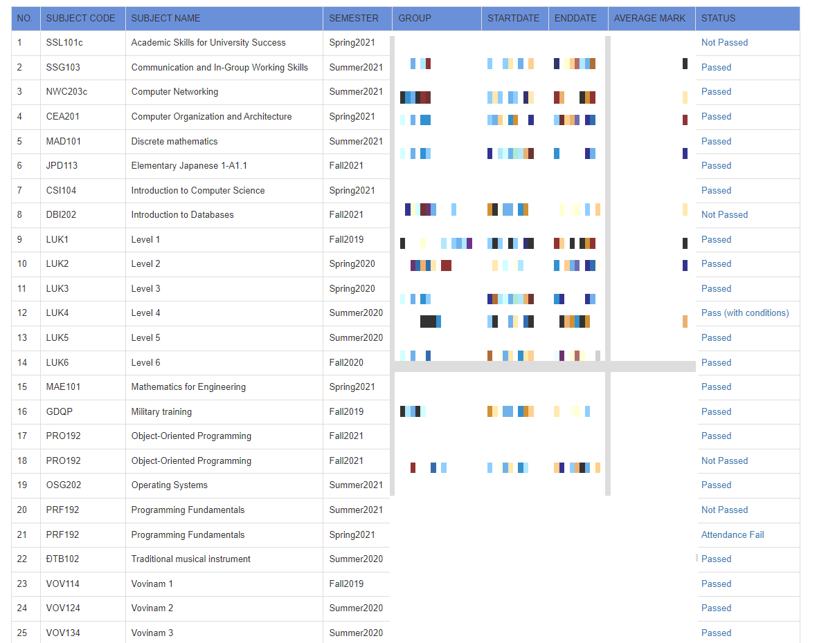

**Field:**

* No
* Subject Name
* Semester
* Group
* StartDate
* EndDate
* Avarage Mark
* Status

**Table 3: Subject Mark**

**Field and Attributes:**

* Grade Category: Quiz 1, Quiz 2, Activity, Group Assignment, Group Project, Final Exam(FE), Final Exam Resit(FER).
* Grade item: Grade Category, Total.
* Weight: 7%(Quiz 2), 8%(Quiz 1), 10%(Activity), 15%(Group Assignment), 30%(FE and FER)
* Value
* Comment
* Course total: Average, Status.

**Condition:** Total of each Grade Category > 0, FE > 4, Avarage >= 5

### 2> The database must consist of at least six tables that have been populated with data. The database is to support queries that would typically be submitted to the system for the topical area that you have chosen. You must do the following:

Self-investigation for the requirement of the system. Listed them all as form of reports, business rules.

· Using UML, Chen’s notation to create an Entity Relationship (ER) model for your relational database. All entity types, their attributes and relationships must be clearly shown. You will also be required to show all cardinality and participation constraints. You should use some enhanced ER features in your conceptual model where it makes sense to do so.

· Map the EER model devised in part (1) into a relational data model. It must be normalised up to at least 3rd Normal Form.

· Using appropriate SQL commands create a set of database tables in MS SQL Server 2008+. You should also show all constraints used in the creation of the tables.

· Populate the database with a small amount of data. The data should be meaningful but does not need to be extensive. The following sites may be useful for quickly generating data:

♣ <http://www.databasetestdata.com/> ♣ <http://www.generatedata.com/>

• Your database must contain one view, one trigger, on store procedure and an index (describe why).

• Create 10 sample queries that demonstrate the expressiveness of your database system. Your queries must demonstrate different aspects of the system.

## Final Report

You must submit a brief final report which must include the following:

a) A brief description of the database including any assumptions made during the design (THIS IS VERY IMPORTANT TO CLERIFY THE ASSUMTIONS in form of business rules).

b) An ERD (Entity Relationship Diagram) that fully describes the database (giving descriptions on your work would be appreciated).

c) The relational schema derived from the ERD that is at least in 3NF (Any detail of the process would be appreciated).

d) The set of database statements used to create the tables used in your database. You do NOT need to include all the data and insert statements.

e) 10 queries that demonstrate the usefulness of the database. Also state why and when each query would be used. The following must be demonstrated by at least one of your queries:

* A query that uses ORDER BY
* A query that uses INNER JOINS
* A query that uses aggregate functions
* A query that uses the GROUP BY and HAVING clauses
* A query that uses a sub-query as a relation
* A query that uses a sub-query in the WHERE clause
* A query that uses partial matching in the WHERE clause
* A query that uses a self-JOIN f) The trigger, store procedure, and the index should be added (explain why you make it) Demonstration You will be required to briefly demonstrate your system in one of the laboratory sessions prior to submission of the report.

**Bài Làm**

1. **Phân tích đề bài yêu cầu**

- Theo em thấy, **Student Grading Management Sub-System** cần có 3 bảng

* Bảng 1 : Assessment

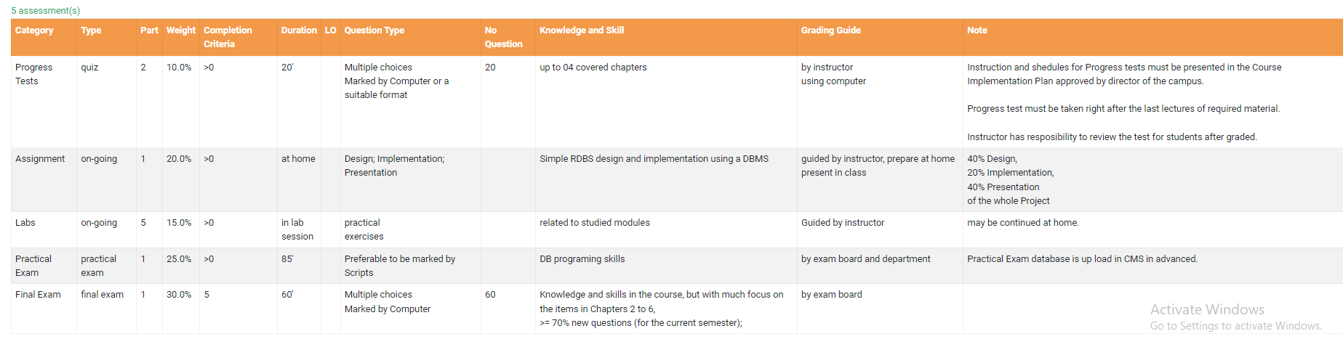

Có 10 attributes : Category, Type, Part, Weight, Completion Criteria,

Duration, LO, Question Type, No Question, Knowledge and Skill

-Category :

+Biểu thị những thành phần điểm

+Data type: varchar(15) 🡺 primary key

+Not null

-Type:

+Biểu thị hình thức kiểm tra

+Data type: varchar(15)

+Not null

-Part:

+Biểu thị số lượng bài kiểm tra

+Data type: int()

+Not null

-Weight:

+Phần trăm số điểm của từng category

+Data type: varchar(5)

+Not null

-Completion Criteria:

+Mức điểm tối thiểu cần đạt của từng category

+Data type:

+Not null

-Duration:

+Thời lượng của từng category

+Data type: varchar(20)

+Not null

-LO

+

-Question Type:

+Biểu thị cách thức kiểm tra

+Data type: varchar(100)

+Not null

-NO question:

+

-Knowledge and Skill:

+Những kiến thức và kĩ năng cần nắm vững

+Data type: varchar(100)

+Not null

*Bảng 2 : Subject and Course



Có 9 attributes : No , Subject Code , Subject Name , Semester , Group , Startdate , Enddate , AverageMark , Status

-NO:

+ Số lượng môn , khóa học

+ Data type : int

+ Not null

-Subject Code :

+ Mã môn học

+Data type : varchar(100)

+ Not null

-Subject Name :

+ Tên đầy đủ của môn học

+ Data type : varchar(100)

+Not null

-Semester :

+ Hiển thị kì học

+ Data type : int

+ Not null

-Group :

+ Tên lớp học theo kì học và khóa học

+ Data type : varchar(100)

+ Not null

-StartDate :

+ Thời gian bắt đầu kì học

+ Data type : Datetime

+ Not null

-Enddate :

+ Thời gian kết thúc kì học

+ Datatype : Datetime

+Not null

-Average Mark :

+ Điểm số trung bình

+ Data type : int

+ Not null

-Status :

+ Mô tả tổng kết quá trình học của sinh viên :

. Passed

.Not Passed

.Passed with condition

*Bảng 3 : Bảng điểm cá nhân của sinh viên

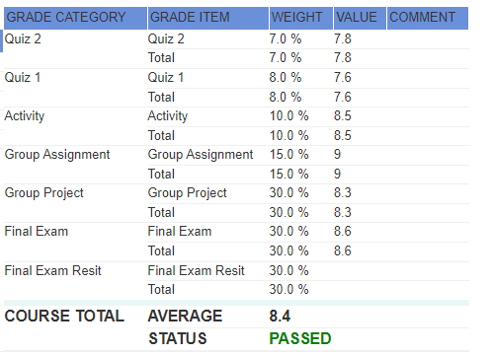

Có 5 attributes : Grade category , Grade item , weight , value ,comment

-Grade category :

+Danh sách và tên các đầu điểm :

- Progress Tests ( Quiz )

- Assignment ( Person, Group )

- Labs

- PE ( Practice Exam )

- FE ( Final Exam )

- Final Exam Resit

- Grade item :

+ Tên và tổng đầu điểm :

. Item

. Total

-Weight :

+ Tỉ lệ % điểm thành phần , cũng có ở bên FLM

+Data type: varchar(5)

+Not null

-Value :

+ Điểm sinh viên đạt được trên thang điểm quy chuẩn

+ Data type : int

+ Not null

**II .Xác định các entities và relationships**

**Xác định các entities** :

Thực Thể 1: Student

- StudentID

-FirstName

-LastName

- DoB

- Gender

- Address

-Email

Thực Thể 2: Class

- ClassID

- ClassName

- EndDate

- StartDate

Thực thể 3 : Student_Class

-ClassID

-StudentID

Thực Thể 5: Subject

- SubjectID

- SubjectName

Thực Thể 4: Lecture

- LecID

- Email

- Firstname

- Lastname

- Gender

- Dob

-Report

Thực Thể 6: Class_Lecture

- ClassID

- LecID

Thực thể 7:Grade

-GradeID

-SubjectID

-Total

-Status

Thực Thể 8: Grade_ Detail

-ID

- GradeID

- weight

- SubjectID

- Item

- value

- comment

Thực Thể 9: Subject_Term

- idSubject

- idTerm

Thực Thể 10: Term

- _TermID

- TermName

Thực Thể 11: Student_subject

-StudentID

-SubjectID

## **ERD Database**

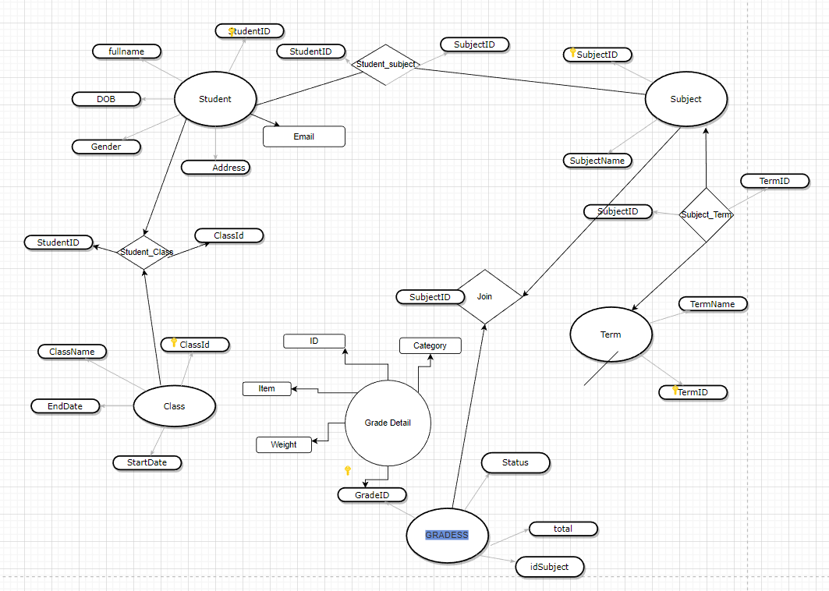

**III . Phân Chia Các Entities Và Relationships**

## Entity Students <-> Entity Class

Mô Tả: Một Student có thể đăng kí học nhiều Class Và 1 Class có thể có nhiều Student đăng kí học.

-> Xác Định Quan Hệ Giữa Entity Students Và Entity Class là quan hệ nhiều nhiều ( n-n )

🡺 Bảng Student_Class được tạo ra

## Entity Class <-> Entity Lecturers

Mô Tả: Một Class chỉ có thể được phụ trách bởi đúng 1 Lecturer và 1 Lecturer có thể phụ trách nhiều class.

-> Xác Định Quan Hệ Giữa Entity Class Và Entity Lecturers là quan hệ một nhiều ( 1-n )

## Entity Student <-> Entity Subject

Mô Tả: Một Student có thể đăng kí học nhiều Subject Và 1 Subject có thể có nhiều Student đăng kí học.

-> Xác Định Quan Hệ Giữa Entity Students Và Entity Class là quan hệ nhiều nhiều (n-n)

🡺Bảng Student_Subject được tạo ra

## Entity Term<-> Entity Subject

Mô Tả: Một kì học có thể có nhiều Subject Và 1 Subject có thể xuất hiện nhiều tại 1 kì học.

-> Xác Định Quan Hệ Giữa Entity Students Và Entity Class là quan hệ nhiều nhiều (n-n)

🡺 Bảng Subject_Term được tạo ra

## Entity Grade Detail<-> Entity Grade

Mô tả :Một Grades có thể tổng hợp từ nhiều Grade Detail và 1 Grade Detail chỉ có thể đưa vào 1 Grade duy nhất.

-> Xác Định Quan Hệ Giữa Entity Grade Và Entity Grade Detail là quan hệ một nhiều ( 1-n )

## Entity Grade <-> Entity Subject

Mô tả :Một Grades có thể mô tả điểm của nhiều Subject nhưng 1 Subject chỉ có thể đưa vào bảng điểm 1 Grade duy nhất.

-> Xác Định Quan Hệ Giữa Entity Grade Và Entity Subject là quan hệ một nhiều ( 1-n )

## **Chuẩn Hóa Thuộc Tính Các Attribute Trên Từng Bảng**

1. **Table Students**

|  |  |
| --- | --- |
| **Atrtributes** | **Type** |
| StudentID | Varchar(10) |
| FirstName | Nvarchar(10) |
| LastName | Nvarchar(50) |
| DoB | Date |
| Address | Nvarchar(150) |
| Email | Varchar(100) |
| Gender | bit |

1. **Table Class**

|  |  |
| --- | --- |
| **Attributes** | **Type** |
| ClassID | Int |
| ClassName | Varchar(50) |
| Start_Date | Date |
| End_Date | Date |

1. **Table Student_Class**

|  |  |
| --- | --- |
| **Attributes** | **Type** |
| ClassID | Int |
| StudentID | Varchar(10) |

1. **Table Lecture**

|  |  |
| --- | --- |
| **Attributes** | **Type** |
| LecID | Int |
| Email | Varchar(100) |
| FirstName | Nvarchar(10) |
| LastName | Nvarchar(50) |
| Gender | Bit |
| Dob | Date |
| Report | Nvarchar(50) |

1. **Table Class_Lecture**

|  |  |
| --- | --- |
| **Attributes** | **Type** |
| LecID | Int |
| ClassID | int |

1. **Table Subjects**

|  |  |
| --- | --- |
| **Attributes** | **Type** |
| SubjectID | Int |
| SubjectName | Varchar(50) |

1. **Table Student_Subject**

|  |  |
| --- | --- |
| **Attributes** | **Type** |
| StudentID | Varchar(10) |
| SubjectID | Int |

1. **Table Term**

|  |  |
| --- | --- |
| **Attributes** | **Type** |
| TermID | Int |
| TermName | Varchar(50) |

1. **Table Subject_Term**

|  |  |
| --- | --- |
| **Attributes** | **Type** |
| TermID | Int |
| SubjectID | int |

1. **Table Grade**

|  |  |
| --- | --- |
| **Attributes** | **Type** |
| GradeID | Int |
| Status | Varchar(255) |
| SubjectID | Int |
| Total | Float |

1. **Table Grade Detail**

|  |  |
| --- | --- |
| **Attributes** | **Type** |
| ID | Int |
| GradeID | Int |
| Weight | Int |
| Category | Nchar(255) |
| Item | Nchar(255) |
| Comment | Nchar(255) |
| Value | float |

## **Xác Định Primary Key, Foriegn Key, Attributes Các TABLES**

1. **Table Students**

|  |  |  |  |
| --- | --- | --- | --- |
| **Atrtributes** | **Type** | **Requires** | **Key** |
| StudentID | Varchar(10) | Not null | Primary key |
| FirstName | Nvarchar(10) | Not null |  |
| LastName | Nvarchar(50) | Not null |  |
| DoB | Date | Not null |  |
| Address | Nvarchar(150) | null |  |
| Email | Varchar(100) | Null |  |
| Gender | bit | Not null |  |

1. **Table Class**

|  |  |  |  |
| --- | --- | --- | --- |
| **Attributes** | **Type** | **Requires** | **Key** |
| ClassID | Int | Not null | Primary key |
| ClassName | Varchar(50) | Not null |  |
| Start_Date | Date | Not null |  |
| End_Date | Date | Not null |  |

1. **Table Student_Class**

|  |  |  |  |
| --- | --- | --- | --- |
| **Attributes** | **Type** | **Requires** | **Key** |
| ClassID | Int | Not null | Primary _ ForeignKey |
| StudentID | Varchar(10) | Not null | Primary _ ForeignKey |

1. **Table Lecture**

|  |  |  |  |
| --- | --- | --- | --- |
| **Attributes** | **Type** | **Requires** | **Key** |
| LecID | Int | Not null | Primary key |
| Email | Varchar(100) | Not null |  |
| FirstName | Nvarchar(10) | Not null |  |
| LastName | Nvarchar(50) | Not null |  |
| Gender | Bit | Null |  |
| Dob | Date | Null |  |
| Report | Nvarchar(50) | Null |  |

1. **Table Class_Lecture**

|  |  |  |  |
| --- | --- | --- | --- |
| **Attributes** | **Type** | **Requires** | **Key** |
| LecID | Int | Not null | Primary_Foreign key |
| ClassID | int | Not null | Primary_Foreign key |

1. **Table Subjects**

|  |  |  |  |
| --- | --- | --- | --- |
| **Attributes** | **Type** | **Requires** | **Key** |
| SubjectID | Int | Not null | Primary key |
| SubjectName | Varchar(50) | Not null |  |

1. **Table Student_Subject**

|  |  |  |  |
| --- | --- | --- | --- |
| **Attributes** | **Type** | **Requires** | **Key** |
| StudentID | Varchar(10) | Not null | Primary_Foreign key |
| SubjectID | Int | Not null | Primary_Foreign key |

1. **Table Term**

|  |  |  |  |
| --- | --- | --- | --- |
| **Attributes** | **Type** | **Requires** | **Key** |
| TermID | Int | Not null | Primary key |
| TermName | Varchar(50) | Not null |  |

1. **Table Subject_Term**

|  |  |  |  |
| --- | --- | --- | --- |
| **Attributes** | **Type** | **Requires** | **Key** |
| TermID | Int | Not null | Primary_Foreign key |
| SubjectID | int | Not null | Primary_Foreign key |

1. **Table Grade**

|  |  |  |  |
| --- | --- | --- | --- |
| **Attributes** | **Type** | **Requires** | **Key** |
| GradeID | Int | Not null | Primary key |
| Status | Varchar(255) | Null |  |
| SubjectID | Int | Not null | Foreign key |
| Total | Float | Null |  |

1. **Table Grade Detail**

|  |  |  |  |
| --- | --- | --- | --- |
| **Attributes** | **Type** | **Requires** | **Key** |
| ID | Int | Not null | Primary key |
| GradeID | Int | Not null | Foreign key |
| Weight | Int | Null |  |
| Category | Nchar(255) | Null |  |
| Item | Nchar(255) | Null |  |
| Comment | Nchar(255) | Null |  |
| Value | float | Not null |  |

## **Database_Diagram và code Sql**

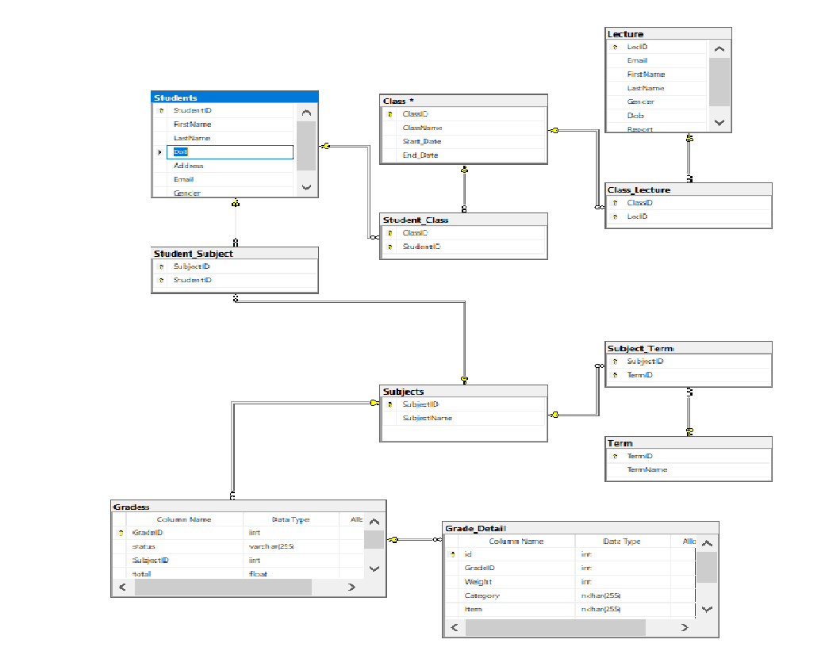

USE [master]

GO

/****** Object: Database [Assignment_ DBI202] Script Date: 7/15/2022 11:07:05 PM ******/

CREATE DATABASE [Assignment_ DBI202]

CONTAINMENT = NONE

ON PRIMARY

( NAME = N'Assignment_ DBI202', FILENAME = N'C:\Program Files\Microsoft SQL Server\MSSQL15.MAYAO\MSSQL\DATA\Assignment_ DBI202.mdf' , SIZE = 8192KB , MAXSIZE = UNLIMITED, FILEGROWTH = 65536KB )

LOG ON

( NAME = N'Assignment_ DBI202_log', FILENAME = N'C:\Program Files\Microsoft SQL Server\MSSQL15.MAYAO\MSSQL\DATA\Assignment_ DBI202_log.ldf' , SIZE = 8192KB , MAXSIZE = 2048GB , FILEGROWTH = 65536KB )

WITH CATALOG_COLLATION = DATABASE_DEFAULT

GO

ALTER DATABASE [Assignment_ DBI202] SET COMPATIBILITY_LEVEL = 150

GO

IF (1 = FULLTEXTSERVICEPROPERTY('IsFullTextInstalled'))

begin

EXEC [Assignment_ DBI202].[dbo].[sp_fulltext_database] @action = 'enable'

end

GO

ALTER DATABASE [Assignment_ DBI202] SET ANSI_NULL_DEFAULT OFF

GO

ALTER DATABASE [Assignment_ DBI202] SET ANSI_NULLS OFF

GO

ALTER DATABASE [Assignment_ DBI202] SET ANSI_PADDING OFF

GO

ALTER DATABASE [Assignment_ DBI202] SET ANSI_WARNINGS OFF

GO

ALTER DATABASE [Assignment_ DBI202] SET ARITHABORT OFF

GO

ALTER DATABASE [Assignment_ DBI202] SET AUTO_CLOSE OFF

GO

ALTER DATABASE [Assignment_ DBI202] SET AUTO_SHRINK OFF

GO

ALTER DATABASE [Assignment_ DBI202] SET AUTO_UPDATE_STATISTICS ON

GO

ALTER DATABASE [Assignment_ DBI202] SET CURSOR_CLOSE_ON_COMMIT OFF

GO

ALTER DATABASE [Assignment_ DBI202] SET CURSOR_DEFAULT GLOBAL

GO

ALTER DATABASE [Assignment_ DBI202] SET CONCAT_NULL_YIELDS_NULL OFF

GO

ALTER DATABASE [Assignment_ DBI202] SET NUMERIC_ROUNDABORT OFF

GO

ALTER DATABASE [Assignment_ DBI202] SET QUOTED_IDENTIFIER OFF

GO

ALTER DATABASE [Assignment_ DBI202] SET RECURSIVE_TRIGGERS OFF

GO

ALTER DATABASE [Assignment_ DBI202] SET DISABLE_BROKER

GO

ALTER DATABASE [Assignment_ DBI202] SET AUTO_UPDATE_STATISTICS_ASYNC OFF

GO

ALTER DATABASE [Assignment_ DBI202] SET DATE_CORRELATION_OPTIMIZATION OFF

GO

ALTER DATABASE [Assignment_ DBI202] SET TRUSTWORTHY OFF

GO

ALTER DATABASE [Assignment_ DBI202] SET ALLOW_SNAPSHOT_ISOLATION OFF

GO

ALTER DATABASE [Assignment_ DBI202] SET PARAMETERIZATION SIMPLE

GO

ALTER DATABASE [Assignment_ DBI202] SET READ_COMMITTED_SNAPSHOT OFF

GO

ALTER DATABASE [Assignment_ DBI202] SET HONOR_BROKER_PRIORITY OFF

GO

ALTER DATABASE [Assignment_ DBI202] SET RECOVERY FULL

GO

ALTER DATABASE [Assignment_ DBI202] SET MULTI_USER

GO

ALTER DATABASE [Assignment_ DBI202] SET PAGE_VERIFY CHECKSUM

GO

ALTER DATABASE [Assignment_ DBI202] SET DB_CHAINING OFF

GO

ALTER DATABASE [Assignment_ DBI202] SET FILESTREAM( NON_TRANSACTED_ACCESS = OFF )

GO

ALTER DATABASE [Assignment_ DBI202] SET TARGET_RECOVERY_TIME = 60 SECONDS

GO

ALTER DATABASE [Assignment_ DBI202] SET DELAYED_DURABILITY = DISABLED

GO

ALTER DATABASE [Assignment_ DBI202] SET ACCELERATED_DATABASE_RECOVERY = OFF

GO

EXEC sys.sp_db_vardecimal_storage_format N'Assignment_ DBI202', N'ON'

GO

ALTER DATABASE [Assignment_ DBI202] SET QUERY_STORE = OFF

GO

USE [Assignment_ DBI202]

GO

/****** Object: Table [dbo].[Class] Script Date: 7/15/2022 11:07:05 PM ******/

SET ANSI_NULLS ON

GO

SET QUOTED_IDENTIFIER ON

GO

CREATE TABLE [dbo].[Class](

[ClassID] [int] NOT NULL,

[ClassName] [varchar](50) NOT NULL,

[Start_Date] [date] NOT NULL,

[End_Date] [date] NOT NULL,

CONSTRAINT [PK_Class] PRIMARY KEY CLUSTERED

(

[ClassID] ASC

)WITH (PAD_INDEX = OFF, STATISTICS_NORECOMPUTE = OFF, IGNORE_DUP_KEY = OFF, ALLOW_ROW_LOCKS = ON, ALLOW_PAGE_LOCKS = ON, OPTIMIZE_FOR_SEQUENTIAL_KEY = OFF) ON [PRIMARY]

) ON [PRIMARY]

GO

/****** Object: Table [dbo].[Class_Lecture] Script Date: 7/15/2022 11:07:05 PM ******/

SET ANSI_NULLS ON

GO

SET QUOTED_IDENTIFIER ON

GO

CREATE TABLE [dbo].[Class_Lecture](

[ClassID] [int] NOT NULL,

[LecID] [int] NOT NULL,

CONSTRAINT [PK_Class_Lecture] PRIMARY KEY CLUSTERED

(

[ClassID] ASC,

[LecID] ASC

)WITH (PAD_INDEX = OFF, STATISTICS_NORECOMPUTE = OFF, IGNORE_DUP_KEY = OFF, ALLOW_ROW_LOCKS = ON, ALLOW_PAGE_LOCKS = ON, OPTIMIZE_FOR_SEQUENTIAL_KEY = OFF) ON [PRIMARY]

) ON [PRIMARY]

GO

/****** Object: Table [dbo].[Grade_Detail] Script Date: 7/15/2022 11:07:05 PM ******/

SET ANSI_NULLS ON

GO

SET QUOTED_IDENTIFIER ON

GO

CREATE TABLE [dbo].[Grade_Detail](

[id] [int] NOT NULL,

[GradeID] [int] NOT NULL,

[Weight] [int] NULL,

[Category] [nchar](255) NULL,

[Item] [nchar](255) NULL,

[Comment] [nchar](255) NULL,

[Value] [float] NOT NULL,

CONSTRAINT [PK_Grade_Detail] PRIMARY KEY CLUSTERED

(

[id] ASC

)WITH (PAD_INDEX = OFF, STATISTICS_NORECOMPUTE = OFF, IGNORE_DUP_KEY = OFF, ALLOW_ROW_LOCKS = ON, ALLOW_PAGE_LOCKS = ON, OPTIMIZE_FOR_SEQUENTIAL_KEY = OFF) ON [PRIMARY]

) ON [PRIMARY]

GO

/****** Object: Table [dbo].[Gradess] Script Date: 7/15/2022 11:07:05 PM ******/

SET ANSI_NULLS ON

GO

SET QUOTED_IDENTIFIER ON

GO

CREATE TABLE [dbo].[Gradess](

[GradeID] [int] NOT NULL,

[status] [varchar](255) NULL,

[SubjectID] [int] NOT NULL,

[total] [float] NULL,

CONSTRAINT [PK_Gradess] PRIMARY KEY CLUSTERED

(

[GradeID] ASC

)WITH (PAD_INDEX = OFF, STATISTICS_NORECOMPUTE = OFF, IGNORE_DUP_KEY = OFF, ALLOW_ROW_LOCKS = ON, ALLOW_PAGE_LOCKS = ON, OPTIMIZE_FOR_SEQUENTIAL_KEY = OFF) ON [PRIMARY]

) ON [PRIMARY]

GO

/****** Object: Table [dbo].[Lecture] Script Date: 7/15/2022 11:07:05 PM ******/

SET ANSI_NULLS ON

GO

SET QUOTED_IDENTIFIER ON

GO

CREATE TABLE [dbo].[Lecture](

[LecID] [int] NOT NULL,

[Email] [varchar](100) NOT NULL,

[FirstName] [nvarchar](10) NOT NULL,

[LastName] [nvarchar](50) NOT NULL,

[Gender] [bit] NULL,

[Dob] [date] NULL,

[Report] [nvarchar](50) NULL,

CONSTRAINT [PK_Lecture] PRIMARY KEY CLUSTERED

(

[LecID] ASC

)WITH (PAD_INDEX = OFF, STATISTICS_NORECOMPUTE = OFF, IGNORE_DUP_KEY = OFF, ALLOW_ROW_LOCKS = ON, ALLOW_PAGE_LOCKS = ON, OPTIMIZE_FOR_SEQUENTIAL_KEY = OFF) ON [PRIMARY]

) ON [PRIMARY]

GO

/****** Object: Table [dbo].[Student_Class] Script Date: 7/15/2022 11:07:05 PM ******/

SET ANSI_NULLS ON

GO

SET QUOTED_IDENTIFIER ON

GO

CREATE TABLE [dbo].[Student_Class](

[ClassID] [int] NOT NULL,

[StudentID] [varchar](10) NOT NULL,

CONSTRAINT [PK_Student_Class] PRIMARY KEY CLUSTERED

(

[ClassID] ASC,

[StudentID] ASC

)WITH (PAD_INDEX = OFF, STATISTICS_NORECOMPUTE = OFF, IGNORE_DUP_KEY = OFF, ALLOW_ROW_LOCKS = ON, ALLOW_PAGE_LOCKS = ON, OPTIMIZE_FOR_SEQUENTIAL_KEY = OFF) ON [PRIMARY]

) ON [PRIMARY]

GO

/****** Object: Table [dbo].[Student_Subject] Script Date: 7/15/2022 11:07:05 PM ******/

SET ANSI_NULLS ON

GO

SET QUOTED_IDENTIFIER ON

GO

CREATE TABLE [dbo].[Student_Subject](

[SubjectID] [int] NOT NULL,

[StudentID] [varchar](10) NOT NULL,

CONSTRAINT [PK_Student_Subject] PRIMARY KEY CLUSTERED

(

[SubjectID] ASC,

[StudentID] ASC

)WITH (PAD_INDEX = OFF, STATISTICS_NORECOMPUTE = OFF, IGNORE_DUP_KEY = OFF, ALLOW_ROW_LOCKS = ON, ALLOW_PAGE_LOCKS = ON, OPTIMIZE_FOR_SEQUENTIAL_KEY = OFF) ON [PRIMARY]

) ON [PRIMARY]

GO

/****** Object: Table [dbo].[Students] Script Date: 7/15/2022 11:07:05 PM ******/

SET ANSI_NULLS ON

GO

SET QUOTED_IDENTIFIER ON

GO

CREATE TABLE [dbo].[Students](

[StudentID] [varchar](10) NOT NULL,

[FirstName] [nvarchar](10) NOT NULL,

[LastName] [nvarchar](50) NOT NULL,

[DoB] [date] NOT NULL,

[Address] [nvarchar](150) NULL,

[Email] [varchar](100) NULL,

[Gender] [bit] NULL,

CONSTRAINT [PK_Students] PRIMARY KEY CLUSTERED

(

[StudentID] ASC

)WITH (PAD_INDEX = OFF, STATISTICS_NORECOMPUTE = OFF, IGNORE_DUP_KEY = OFF, ALLOW_ROW_LOCKS = ON, ALLOW_PAGE_LOCKS = ON, OPTIMIZE_FOR_SEQUENTIAL_KEY = OFF) ON [PRIMARY]

) ON [PRIMARY]

GO

/****** Object: Table [dbo].[Subject_Term] Script Date: 7/15/2022 11:07:05 PM ******/

SET ANSI_NULLS ON

GO

SET QUOTED_IDENTIFIER ON

GO

CREATE TABLE [dbo].[Subject_Term](

[SubjectID] [int] NOT NULL,

[TermID] [int] NOT NULL,

CONSTRAINT [PK_Subject_Term] PRIMARY KEY CLUSTERED

(

[SubjectID] ASC,

[TermID] ASC

)WITH (PAD_INDEX = OFF, STATISTICS_NORECOMPUTE = OFF, IGNORE_DUP_KEY = OFF, ALLOW_ROW_LOCKS = ON, ALLOW_PAGE_LOCKS = ON, OPTIMIZE_FOR_SEQUENTIAL_KEY = OFF) ON [PRIMARY]

) ON [PRIMARY]

GO

/****** Object: Table [dbo].[Subjects] Script Date: 7/15/2022 11:07:05 PM ******/

SET ANSI_NULLS ON

GO

SET QUOTED_IDENTIFIER ON

GO

CREATE TABLE [dbo].[Subjects](

[SubjectID] [int] NOT NULL,

[SubjectName] [varchar](50) NOT NULL,

CONSTRAINT [PK_Subjects] PRIMARY KEY CLUSTERED

(

[SubjectID] ASC

)WITH (PAD_INDEX = OFF, STATISTICS_NORECOMPUTE = OFF, IGNORE_DUP_KEY = OFF, ALLOW_ROW_LOCKS = ON, ALLOW_PAGE_LOCKS = ON, OPTIMIZE_FOR_SEQUENTIAL_KEY = OFF) ON [PRIMARY]

) ON [PRIMARY]

GO

/****** Object: Table [dbo].[Term] Script Date: 7/15/2022 11:07:05 PM ******/

SET ANSI_NULLS ON

GO

SET QUOTED_IDENTIFIER ON

GO

CREATE TABLE [dbo].[Term](

[TermID] [int] NOT NULL,

[TermName] [varchar](50) NOT NULL,

CONSTRAINT [PK_Term] PRIMARY KEY CLUSTERED

(

[TermID] ASC

)WITH (PAD_INDEX = OFF, STATISTICS_NORECOMPUTE = OFF, IGNORE_DUP_KEY = OFF, ALLOW_ROW_LOCKS = ON, ALLOW_PAGE_LOCKS = ON, OPTIMIZE_FOR_SEQUENTIAL_KEY = OFF) ON [PRIMARY]

) ON [PRIMARY]

GO

INSERT [dbo].[Class] ([ClassID], [ClassName], [Start_Date], [End_Date]) VALUES (1, N'IA1604', CAST(N'2022-05-09' AS Date), CAST(N'2022-08-09' AS Date))

INSERT [dbo].[Class] ([ClassID], [ClassName], [Start_Date], [End_Date]) VALUES (2, N'AI1601', CAST(N'2022-05-09' AS Date), CAST(N'2022-08-09' AS Date))

INSERT [dbo].[Class] ([ClassID], [ClassName], [Start_Date], [End_Date]) VALUES (3, N'SE1602', CAST(N'2022-09-09' AS Date), CAST(N'2022-11-09' AS Date))

INSERT [dbo].[Class] ([ClassID], [ClassName], [Start_Date], [End_Date]) VALUES (4, N'IA1605', CAST(N'2022-05-09' AS Date), CAST(N'2022-08-09' AS Date))

INSERT [dbo].[Class] ([ClassID], [ClassName], [Start_Date], [End_Date]) VALUES (5, N'IA1606', CAST(N'2022-05-09' AS Date), CAST(N'2022-08-09' AS Date))

INSERT [dbo].[Class] ([ClassID], [ClassName], [Start_Date], [End_Date]) VALUES (6, N'IA1607', CAST(N'2022-05-09' AS Date), CAST(N'2022-08-09' AS Date))

INSERT [dbo].[Class] ([ClassID], [ClassName], [Start_Date], [End_Date]) VALUES (7, N'AI1602', CAST(N'2022-09-09' AS Date), CAST(N'2022-11-09' AS Date))

INSERT [dbo].[Class] ([ClassID], [ClassName], [Start_Date], [End_Date]) VALUES (9, N'AI1603', CAST(N'2022-09-09' AS Date), CAST(N'2022-11-09' AS Date))

INSERT [dbo].[Class] ([ClassID], [ClassName], [Start_Date], [End_Date]) VALUES (10, N'AI1604', CAST(N'2022-09-09' AS Date), CAST(N'2022-11-09' AS Date))

INSERT [dbo].[Class] ([ClassID], [ClassName], [Start_Date], [End_Date]) VALUES (11, N'SE1603', CAST(N'2022-09-09' AS Date), CAST(N'2022-11-09' AS Date))

INSERT [dbo].[Class] ([ClassID], [ClassName], [Start_Date], [End_Date]) VALUES (12, N'SE1604', CAST(N'2022-04-06' AS Date), CAST(N'2022-07-01' AS Date))

GO

INSERT [dbo].[Class_Lecture] ([ClassID], [LecID]) VALUES (1, 1)

INSERT [dbo].[Class_Lecture] ([ClassID], [LecID]) VALUES (1, 2)

INSERT [dbo].[Class_Lecture] ([ClassID], [LecID]) VALUES (1, 3)

INSERT [dbo].[Class_Lecture] ([ClassID], [LecID]) VALUES (2, 1)

INSERT [dbo].[Class_Lecture] ([ClassID], [LecID]) VALUES (2, 2)

INSERT [dbo].[Class_Lecture] ([ClassID], [LecID]) VALUES (2, 3)

INSERT [dbo].[Class_Lecture] ([ClassID], [LecID]) VALUES (2, 4)

INSERT [dbo].[Class_Lecture] ([ClassID], [LecID]) VALUES (3, 1)

INSERT [dbo].[Class_Lecture] ([ClassID], [LecID]) VALUES (3, 2)

INSERT [dbo].[Class_Lecture] ([ClassID], [LecID]) VALUES (3, 5)

INSERT [dbo].[Class_Lecture] ([ClassID], [LecID]) VALUES (4, 1)

INSERT [dbo].[Class_Lecture] ([ClassID], [LecID]) VALUES (4, 2)

INSERT [dbo].[Class_Lecture] ([ClassID], [LecID]) VALUES (4, 5)

INSERT [dbo].[Class_Lecture] ([ClassID], [LecID]) VALUES (4, 9)

INSERT [dbo].[Class_Lecture] ([ClassID], [LecID]) VALUES (5, 1)

INSERT [dbo].[Class_Lecture] ([ClassID], [LecID]) VALUES (5, 2)

INSERT [dbo].[Class_Lecture] ([ClassID], [LecID]) VALUES (5, 8)

INSERT [dbo].[Class_Lecture] ([ClassID], [LecID]) VALUES (6, 1)

INSERT [dbo].[Class_Lecture] ([ClassID], [LecID]) VALUES (6, 2)

INSERT [dbo].[Class_Lecture] ([ClassID], [LecID]) VALUES (6, 3)

INSERT [dbo].[Class_Lecture] ([ClassID], [LecID]) VALUES (6, 7)

INSERT [dbo].[Class_Lecture] ([ClassID], [LecID]) VALUES (7, 1)

INSERT [dbo].[Class_Lecture] ([ClassID], [LecID]) VALUES (7, 5)

INSERT [dbo].[Class_Lecture] ([ClassID], [LecID]) VALUES (7, 7)

INSERT [dbo].[Class_Lecture] ([ClassID], [LecID]) VALUES (7, 9)

INSERT [dbo].[Class_Lecture] ([ClassID], [LecID]) VALUES (10, 9)

INSERT [dbo].[Class_Lecture] ([ClassID], [LecID]) VALUES (11, 7)

INSERT [dbo].[Class_Lecture] ([ClassID], [LecID]) VALUES (11, 8)

INSERT [dbo].[Class_Lecture] ([ClassID], [LecID]) VALUES (12, 3)

INSERT [dbo].[Class_Lecture] ([ClassID], [LecID]) VALUES (12, 8)

GO

INSERT [dbo].[Grade_Detail] ([id], [GradeID], [Weight], [Category], [Item], [Comment], [Value]) VALUES (1, 1, 10, N'Avtive learning ', N'Active Learning ', NULL, 7)

INSERT [dbo].[Grade_Detail] ([id], [GradeID], [Weight], [Category], [Item], [Comment], [Value]) VALUES (2, 1, 5, N'Exercise ', N'Excercise 1 ', NULL, 8)

INSERT [dbo].[Grade_Detail] ([id], [GradeID], [Weight], [Category], [Item], [Comment], [Value]) VALUES (3, 1, 5, N'Excercise ', N'Excercise 2 ', NULL, 8.5)

INSERT [dbo].[Grade_Detail] ([id], [GradeID], [Weight], [Category], [Item], [Comment], [Value]) VALUES (4, 1, 10, N'Presentation ', N'Presentation ', NULL, 8)

INSERT [dbo].[Grade_Detail] ([id], [GradeID], [Weight], [Category], [Item], [Comment], [Value]) VALUES (5, 1, 30, N'Assignment ', N'Assignment ', NULL, 8.5)

INSERT [dbo].[Grade_Detail] ([id], [GradeID], [Weight], [Category], [Item], [Comment], [Value]) VALUES (6, 1, 40, N'Final Exam ', N'Final Exam ', NULL, 8)

INSERT [dbo].[Grade_Detail] ([id], [GradeID], [Weight], [Category], [Item], [Comment], [Value]) VALUES (7, 2, 10, N'Active learning ', N'Active learning ', NULL, 7)

INSERT [dbo].[Grade_Detail] ([id], [GradeID], [Weight], [Category], [Item], [Comment], [Value]) VALUES (8, 2, 5, NULL, NULL, NULL, 0)

INSERT [dbo].[Grade_Detail] ([id], [GradeID], [Weight], [Category], [Item], [Comment], [Value]) VALUES (9, 2, 10, N'Presentation ', N'Presentation ', NULL, 5)

INSERT [dbo].[Grade_Detail] ([id], [GradeID], [Weight], [Category], [Item], [Comment], [Value]) VALUES (10, 2, 40, N'Final Exam ', N'Final Exam ', NULL, 3.9)

GO

INSERT [dbo].[Gradess] ([GradeID], [status], [SubjectID], [total]) VALUES (1, N'Passed', 1, 8.1)

INSERT [dbo].[Gradess] ([GradeID], [status], [SubjectID], [total]) VALUES (2, N'Passed', 1, 7)

INSERT [dbo].[Gradess] ([GradeID], [status], [SubjectID], [total]) VALUES (3, N'Passed', 1, 9)

INSERT [dbo].[Gradess] ([GradeID], [status], [SubjectID], [total]) VALUES (4, N'Not passed ', 2, 4.5)

INSERT [dbo].[Gradess] ([GradeID], [status], [SubjectID], [total]) VALUES (5, N'Passed', 1, 5.6)

INSERT [dbo].[Gradess] ([GradeID], [status], [SubjectID], [total]) VALUES (6, N'Not passed', 2, 4.9)

INSERT [dbo].[Gradess] ([GradeID], [status], [SubjectID], [total]) VALUES (7, N'Not passed', 3, 5.9)

INSERT [dbo].[Gradess] ([GradeID], [status], [SubjectID], [total]) VALUES (8, N'Not passed', 3, 3.5)

INSERT [dbo].[Gradess] ([GradeID], [status], [SubjectID], [total]) VALUES (9, N'Passed ', 3, 10)

INSERT [dbo].[Gradess] ([GradeID], [status], [SubjectID], [total]) VALUES (10, N'Passed', 3, 7.6)

INSERT [dbo].[Gradess] ([GradeID], [status], [SubjectID], [total]) VALUES (11, N'Passed', 4, 7)

INSERT [dbo].[Gradess] ([GradeID], [status], [SubjectID], [total]) VALUES (12, N'Passed', 4, 6.7)

INSERT [dbo].[Gradess] ([GradeID], [status], [SubjectID], [total]) VALUES (13, NULL, 4, 0)

INSERT [dbo].[Gradess] ([GradeID], [status], [SubjectID], [total]) VALUES (14, NULL, 4, 0)

INSERT [dbo].[Gradess] ([GradeID], [status], [SubjectID], [total]) VALUES (15, N'Passed', 4, 8.2)

INSERT [dbo].[Gradess] ([GradeID], [status], [SubjectID], [total]) VALUES (16, N'Passed', 5, 7.2)

INSERT [dbo].[Gradess] ([GradeID], [status], [SubjectID], [total]) VALUES (17, N'Not Passed', 5, 2.3)

INSERT [dbo].[Gradess] ([GradeID], [status], [SubjectID], [total]) VALUES (18, NULL, 5, 0)

INSERT [dbo].[Gradess] ([GradeID], [status], [SubjectID], [total]) VALUES (19, NULL, 5, 1.1)

INSERT [dbo].[Gradess] ([GradeID], [status], [SubjectID], [total]) VALUES (20, NULL, 5, 0.2)

INSERT [dbo].[Gradess] ([GradeID], [status], [SubjectID], [total]) VALUES (21, NULL, 5, 0.3)

INSERT [dbo].[Gradess] ([GradeID], [status], [SubjectID], [total]) VALUES (22, NULL, 6, 0)

INSERT [dbo].[Gradess] ([GradeID], [status], [SubjectID], [total]) VALUES (23, N'Passed', 6, 9.8)

INSERT [dbo].[Gradess] ([GradeID], [status], [SubjectID], [total]) VALUES (24, N'Passed', 6, 9.4)

INSERT [dbo].[Gradess] ([GradeID], [status], [SubjectID], [total]) VALUES (25, N'Passed', 6, 9)

INSERT [dbo].[Gradess] ([GradeID], [status], [SubjectID], [total]) VALUES (26, N'Passed', 6, 7.7)

INSERT [dbo].[Gradess] ([GradeID], [status], [SubjectID], [total]) VALUES (27, N'Passed', 6, 6.6)

INSERT [dbo].[Gradess] ([GradeID], [status], [SubjectID], [total]) VALUES (28, N'Passed', 7, 7)

INSERT [dbo].[Gradess] ([GradeID], [status], [SubjectID], [total]) VALUES (29, N'Not passed', 7, 4.4)

INSERT [dbo].[Gradess] ([GradeID], [status], [SubjectID], [total]) VALUES (30, N'Not passed ', 7, 4)

GO

INSERT [dbo].[Lecture] ([LecID], [Email], [FirstName], [LastName], [Gender], [Dob], [Report]) VALUES (1, N'Sonnt5@g.c', N'Sơn', N'NT', 1, CAST(N'1987-05-06' AS Date), NULL)

INSERT [dbo].[Lecture] ([LecID], [Email], [FirstName], [LastName], [Gender], [Dob], [Report]) VALUES (2, N'Antt@g.c', N'Ân', N'TT', 1, CAST(N'1988-02-04' AS Date), N'1')

INSERT [dbo].[Lecture] ([LecID], [Email], [FirstName], [LastName], [Gender], [Dob], [Report]) VALUES (3, N'Nangnt@g.c', N'Năng', N'NT', 0, CAST(N'1990-03-06' AS Date), N'1')

INSERT [dbo].[Lecture] ([LecID], [Email], [FirstName], [LastName], [Gender], [Dob], [Report]) VALUES (4, N'Vandt@g.c', N'Vân', N'DT', 0, CAST(N'1989-08-02' AS Date), NULL)

INSERT [dbo].[Lecture] ([LecID], [Email], [FirstName], [LastName], [Gender], [Dob], [Report]) VALUES (5, N'Duchm@g.c', N'Đức', N'HM', 1, CAST(N'1985-05-01' AS Date), NULL)

INSERT [dbo].[Lecture] ([LecID], [Email], [FirstName], [LastName], [Gender], [Dob], [Report]) VALUES (6, N'Khuongpd@g.c', N'Khương', N'PD', 1, CAST(N'1989-01-11' AS Date), NULL)

INSERT [dbo].[Lecture] ([LecID], [Email], [FirstName], [LastName], [Gender], [Dob], [Report]) VALUES (7, N'Tientd@g.c', N'Tiến', N'TD', 1, CAST(N'1980-05-06' AS Date), N'1')

INSERT [dbo].[Lecture] ([LecID], [Email], [FirstName], [LastName], [Gender], [Dob], [Report]) VALUES (8, N'Mailt@g.c', N'Mai', N'LT', 0, CAST(N'1988-04-16' AS Date), NULL)

INSERT [dbo].[Lecture] ([LecID], [Email], [FirstName], [LastName], [Gender], [Dob], [Report]) VALUES (9, N'Hoakt@g.c', N'Hoa', N'KT', 0, CAST(N'1995-08-18' AS Date), NULL)

GO

INSERT [dbo].[Student_Class] ([ClassID], [StudentID]) VALUES (1, N'HE111')

INSERT [dbo].[Student_Class] ([ClassID], [StudentID]) VALUES (1, N'HE112')

INSERT [dbo].[Student_Class] ([ClassID], [StudentID]) VALUES (1, N'HE113')

INSERT [dbo].[Student_Class] ([ClassID], [StudentID]) VALUES (1, N'HE116')

INSERT [dbo].[Student_Class] ([ClassID], [StudentID]) VALUES (1, N'HE117')

INSERT [dbo].[Student_Class] ([ClassID], [StudentID]) VALUES (1, N'HE118')

INSERT [dbo].[Student_Class] ([ClassID], [StudentID]) VALUES (2, N'HE111')

INSERT [dbo].[Student_Class] ([ClassID], [StudentID]) VALUES (2, N'HE112')

INSERT [dbo].[Student_Class] ([ClassID], [StudentID]) VALUES (2, N'HE114')

INSERT [dbo].[Student_Class] ([ClassID], [StudentID]) VALUES (2, N'HE116')

INSERT [dbo].[Student_Class] ([ClassID], [StudentID]) VALUES (3, N'HE111')

INSERT [dbo].[Student_Class] ([ClassID], [StudentID]) VALUES (3, N'HE113')

INSERT [dbo].[Student_Class] ([ClassID], [StudentID]) VALUES (3, N'HE115')

INSERT [dbo].[Student_Class] ([ClassID], [StudentID]) VALUES (4, N'HE111')

INSERT [dbo].[Student_Class] ([ClassID], [StudentID]) VALUES (4, N'HE112')

INSERT [dbo].[Student_Class] ([ClassID], [StudentID]) VALUES (4, N'HE114')

INSERT [dbo].[Student_Class] ([ClassID], [StudentID]) VALUES (4, N'HE115')

INSERT [dbo].[Student_Class] ([ClassID], [StudentID]) VALUES (4, N'HE119')

INSERT [dbo].[Student_Class] ([ClassID], [StudentID]) VALUES (4, N'HE120')

INSERT [dbo].[Student_Class] ([ClassID], [StudentID]) VALUES (5, N'HE111')

INSERT [dbo].[Student_Class] ([ClassID], [StudentID]) VALUES (5, N'HE113')

INSERT [dbo].[Student_Class] ([ClassID], [StudentID]) VALUES (5, N'HE116')

INSERT [dbo].[Student_Class] ([ClassID], [StudentID]) VALUES (5, N'HE117')

INSERT [dbo].[Student_Class] ([ClassID], [StudentID]) VALUES (5, N'HE118')

INSERT [dbo].[Student_Class] ([ClassID], [StudentID]) VALUES (5, N'HE120')

INSERT [dbo].[Student_Class] ([ClassID], [StudentID]) VALUES (6, N'HE111')

INSERT [dbo].[Student_Class] ([ClassID], [StudentID]) VALUES (6, N'HE112')

INSERT [dbo].[Student_Class] ([ClassID], [StudentID]) VALUES (6, N'HE113')

INSERT [dbo].[Student_Class] ([ClassID], [StudentID]) VALUES (6, N'HE114')

INSERT [dbo].[Student_Class] ([ClassID], [StudentID]) VALUES (6, N'HE115')

INSERT [dbo].[Student_Class] ([ClassID], [StudentID]) VALUES (6, N'HE117')

INSERT [dbo].[Student_Class] ([ClassID], [StudentID]) VALUES (6, N'HE120')

INSERT [dbo].[Student_Class] ([ClassID], [StudentID]) VALUES (7, N'HE111')

INSERT [dbo].[Student_Class] ([ClassID], [StudentID]) VALUES (7, N'HE112')

INSERT [dbo].[Student_Class] ([ClassID], [StudentID]) VALUES (7, N'HE113')

INSERT [dbo].[Student_Class] ([ClassID], [StudentID]) VALUES (7, N'HE117')

INSERT [dbo].[Student_Class] ([ClassID], [StudentID]) VALUES (7, N'HE118')

INSERT [dbo].[Student_Class] ([ClassID], [StudentID]) VALUES (7, N'HE120')

GO

INSERT [dbo].[Student_Subject] ([SubjectID], [StudentID]) VALUES (1, N'HE111')

INSERT [dbo].[Student_Subject] ([SubjectID], [StudentID]) VALUES (1, N'HE112')

INSERT [dbo].[Student_Subject] ([SubjectID], [StudentID]) VALUES (1, N'HE113')

INSERT [dbo].[Student_Subject] ([SubjectID], [StudentID]) VALUES (2, N'HE111')

INSERT [dbo].[Student_Subject] ([SubjectID], [StudentID]) VALUES (2, N'HE113')

INSERT [dbo].[Student_Subject] ([SubjectID], [StudentID]) VALUES (2, N'HE114')

INSERT [dbo].[Student_Subject] ([SubjectID], [StudentID]) VALUES (2, N'HE115')

INSERT [dbo].[Student_Subject] ([SubjectID], [StudentID]) VALUES (3, N'HE111')

INSERT [dbo].[Student_Subject] ([SubjectID], [StudentID]) VALUES (3, N'HE112')

INSERT [dbo].[Student_Subject] ([SubjectID], [StudentID]) VALUES (3, N'HE113')

INSERT [dbo].[Student_Subject] ([SubjectID], [StudentID]) VALUES (3, N'HE114')

INSERT [dbo].[Student_Subject] ([SubjectID], [StudentID]) VALUES (3, N'HE116')

INSERT [dbo].[Student_Subject] ([SubjectID], [StudentID]) VALUES (4, N'HE111')

INSERT [dbo].[Student_Subject] ([SubjectID], [StudentID]) VALUES (4, N'HE116')

INSERT [dbo].[Student_Subject] ([SubjectID], [StudentID]) VALUES (5, N'HE111')

INSERT [dbo].[Student_Subject] ([SubjectID], [StudentID]) VALUES (5, N'HE112')

INSERT [dbo].[Student_Subject] ([SubjectID], [StudentID]) VALUES (5, N'HE115')

INSERT [dbo].[Student_Subject] ([SubjectID], [StudentID]) VALUES (5, N'HE116')

INSERT [dbo].[Student_Subject] ([SubjectID], [StudentID]) VALUES (6, N'HE111')

INSERT [dbo].[Student_Subject] ([SubjectID], [StudentID]) VALUES (6, N'HE112')

INSERT [dbo].[Student_Subject] ([SubjectID], [StudentID]) VALUES (6, N'HE114')

INSERT [dbo].[Student_Subject] ([SubjectID], [StudentID]) VALUES (6, N'HE118')

INSERT [dbo].[Student_Subject] ([SubjectID], [StudentID]) VALUES (6, N'HE120')

INSERT [dbo].[Student_Subject] ([SubjectID], [StudentID]) VALUES (7, N'HE111')

INSERT [dbo].[Student_Subject] ([SubjectID], [StudentID]) VALUES (7, N'HE112')

INSERT [dbo].[Student_Subject] ([SubjectID], [StudentID]) VALUES (7, N'HE113')

INSERT [dbo].[Student_Subject] ([SubjectID], [StudentID]) VALUES (7, N'HE118')

INSERT [dbo].[Student_Subject] ([SubjectID], [StudentID]) VALUES (7, N'HE119')

INSERT [dbo].[Student_Subject] ([SubjectID], [StudentID]) VALUES (7, N'HE120')

INSERT [dbo].[Student_Subject] ([SubjectID], [StudentID]) VALUES (8, N'HE111')

INSERT [dbo].[Student_Subject] ([SubjectID], [StudentID]) VALUES (8, N'HE114')

INSERT [dbo].[Student_Subject] ([SubjectID], [StudentID]) VALUES (8, N'HE115')

INSERT [dbo].[Student_Subject] ([SubjectID], [StudentID]) VALUES (8, N'HE117')

INSERT [dbo].[Student_Subject] ([SubjectID], [StudentID]) VALUES (8, N'HE119')

INSERT [dbo].[Student_Subject] ([SubjectID], [StudentID]) VALUES (8, N'HE120')

INSERT [dbo].[Student_Subject] ([SubjectID], [StudentID]) VALUES (9, N'HE111')

INSERT [dbo].[Student_Subject] ([SubjectID], [StudentID]) VALUES (9, N'HE112')

INSERT [dbo].[Student_Subject] ([SubjectID], [StudentID]) VALUES (9, N'HE116')

INSERT [dbo].[Student_Subject] ([SubjectID], [StudentID]) VALUES (9, N'HE120')

INSERT [dbo].[Student_Subject] ([SubjectID], [StudentID]) VALUES (10, N'HE111')

INSERT [dbo].[Student_Subject] ([SubjectID], [StudentID]) VALUES (10, N'HE112')

INSERT [dbo].[Student_Subject] ([SubjectID], [StudentID]) VALUES (10, N'HE113')

INSERT [dbo].[Student_Subject] ([SubjectID], [StudentID]) VALUES (10, N'HE114')

INSERT [dbo].[Student_Subject] ([SubjectID], [StudentID]) VALUES (10, N'HE116')

INSERT [dbo].[Student_Subject] ([SubjectID], [StudentID]) VALUES (10, N'HE118')

INSERT [dbo].[Student_Subject] ([SubjectID], [StudentID]) VALUES (10, N'HE120')

GO

INSERT [dbo].[Students] ([StudentID], [FirstName], [LastName], [DoB], [Address], [Email], [Gender]) VALUES (N'HE111', N'NV', N'A', CAST(N'2002-05-02' AS Date), NULL, N'He111@g.c', 1)

INSERT [dbo].[Students] ([StudentID], [FirstName], [LastName], [DoB], [Address], [Email], [Gender]) VALUES (N'HE112', N'NB', N'B', CAST(N'2001-02-03' AS Date), N'Việt Nam', N'He112@g.c', 0)

INSERT [dbo].[Students] ([StudentID], [FirstName], [LastName], [DoB], [Address], [Email], [Gender]) VALUES (N'HE113', N'HB', N'C', CAST(N'2002-08-06' AS Date), N'Việt Nam', N'He113@g.c', 0)

INSERT [dbo].[Students] ([StudentID], [FirstName], [LastName], [DoB], [Address], [Email], [Gender]) VALUES (N'HE114', N'KH', N'D', CAST(N'2000-04-05' AS Date), NULL, N'He114@g.c', 1)

INSERT [dbo].[Students] ([StudentID], [FirstName], [LastName], [DoB], [Address], [Email], [Gender]) VALUES (N'HE115', N'BV', N'E', CAST(N'2002-08-06' AS Date), N'Việt Nam', N'He115@g.c', 1)

INSERT [dbo].[Students] ([StudentID], [FirstName], [LastName], [DoB], [Address], [Email], [Gender]) VALUES (N'HE116', N'NT', N'P', CAST(N'2001-07-03' AS Date), N'Mỹ', N'He116@g.c', 0)

INSERT [dbo].[Students] ([StudentID], [FirstName], [LastName], [DoB], [Address], [Email], [Gender]) VALUES (N'HE117', N'NG', N'A', CAST(N'2002-05-03' AS Date), NULL, N'He117@g.c', 1)

INSERT [dbo].[Students] ([StudentID], [FirstName], [LastName], [DoB], [Address], [Email], [Gender]) VALUES (N'HE118', N'NV', N'B', CAST(N'2001-07-15' AS Date), N'Việt Nam', N'He118@g.c', 1)

INSERT [dbo].[Students] ([StudentID], [FirstName], [LastName], [DoB], [Address], [Email], [Gender]) VALUES (N'HE119', N'TV', N'N', CAST(N'2002-11-05' AS Date), N'Việt Nam', N'He119@g.c', 1)

INSERT [dbo].[Students] ([StudentID], [FirstName], [LastName], [DoB], [Address], [Email], [Gender]) VALUES (N'HE120', N'NM', N'H', CAST(N'2001-01-11' AS Date), NULL, N'He120@g.c', 0)

GO

INSERT [dbo].[Subject_Term] ([SubjectID], [TermID]) VALUES (1, 1)

INSERT [dbo].[Subject_Term] ([SubjectID], [TermID]) VALUES (1, 2)

INSERT [dbo].[Subject_Term] ([SubjectID], [TermID]) VALUES (1, 4)

INSERT [dbo].[Subject_Term] ([SubjectID], [TermID]) VALUES (1, 5)

INSERT [dbo].[Subject_Term] ([SubjectID], [TermID]) VALUES (2, 1)

INSERT [dbo].[Subject_Term] ([SubjectID], [TermID]) VALUES (3, 1)

INSERT [dbo].[Subject_Term] ([SubjectID], [TermID]) VALUES (4, 2)

INSERT [dbo].[Subject_Term] ([SubjectID], [TermID]) VALUES (4, 3)

INSERT [dbo].[Subject_Term] ([SubjectID], [TermID]) VALUES (5, 1)

INSERT [dbo].[Subject_Term] ([SubjectID], [TermID]) VALUES (6, 1)

INSERT [dbo].[Subject_Term] ([SubjectID], [TermID]) VALUES (6, 2)

INSERT [dbo].[Subject_Term] ([SubjectID], [TermID]) VALUES (7, 1)

INSERT [dbo].[Subject_Term] ([SubjectID], [TermID]) VALUES (7, 2)

INSERT [dbo].[Subject_Term] ([SubjectID], [TermID]) VALUES (7, 3)

INSERT [dbo].[Subject_Term] ([SubjectID], [TermID]) VALUES (8, 1)

INSERT [dbo].[Subject_Term] ([SubjectID], [TermID]) VALUES (8, 3)

INSERT [dbo].[Subject_Term] ([SubjectID], [TermID]) VALUES (9, 6)

INSERT [dbo].[Subject_Term] ([SubjectID], [TermID]) VALUES (10, 6)

GO

INSERT [dbo].[Subjects] ([SubjectID], [SubjectName]) VALUES (1, N'DBI202')

INSERT [dbo].[Subjects] ([SubjectID], [SubjectName]) VALUES (2, N'LAB211')

INSERT [dbo].[Subjects] ([SubjectID], [SubjectName]) VALUES (3, N'CSD201')

INSERT [dbo].[Subjects] ([SubjectID], [SubjectName]) VALUES (4, N'JPD113')

INSERT [dbo].[Subjects] ([SubjectID], [SubjectName]) VALUES (5, N'IAO202')

INSERT [dbo].[Subjects] ([SubjectID], [SubjectName]) VALUES (6, N'PRO192')

INSERT [dbo].[Subjects] ([SubjectID], [SubjectName]) VALUES (7, N'OSG202')

INSERT [dbo].[Subjects] ([SubjectID], [SubjectName]) VALUES (8, N'SSG104')

INSERT [dbo].[Subjects] ([SubjectID], [SubjectName]) VALUES (9, N'MAD101')

INSERT [dbo].[Subjects] ([SubjectID], [SubjectName]) VALUES (10, N'NWC204')

GO

INSERT [dbo].[Term] ([TermID], [TermName]) VALUES (1, N'Fall2021')

INSERT [dbo].[Term] ([TermID], [TermName]) VALUES (2, N'Spr2022')

INSERT [dbo].[Term] ([TermID], [TermName]) VALUES (3, N'Su2022')

INSERT [dbo].[Term] ([TermID], [TermName]) VALUES (4, N'Su2021')

INSERT [dbo].[Term] ([TermID], [TermName]) VALUES (5, N'Spr2021')

INSERT [dbo].[Term] ([TermID], [TermName]) VALUES (6, N'Fall2022')

GO

ALTER TABLE [dbo].[Class_Lecture] WITH CHECK ADD CONSTRAINT [FK_Class_Lecture_Class] FOREIGN KEY([ClassID])

REFERENCES [dbo].[Class] ([ClassID])

GO

ALTER TABLE [dbo].[Class_Lecture] CHECK CONSTRAINT [FK_Class_Lecture_Class]

GO

ALTER TABLE [dbo].[Class_Lecture] WITH CHECK ADD CONSTRAINT [FK_Class_Lecture_Lecture] FOREIGN KEY([LecID])

REFERENCES [dbo].[Lecture] ([LecID])

GO

ALTER TABLE [dbo].[Class_Lecture] CHECK CONSTRAINT [FK_Class_Lecture_Lecture]

GO

ALTER TABLE [dbo].[Grade_Detail] WITH CHECK ADD CONSTRAINT [FK_Grade_Detail_Gradess1] FOREIGN KEY([GradeID])

REFERENCES [dbo].[Gradess] ([GradeID])

GO

ALTER TABLE [dbo].[Grade_Detail] CHECK CONSTRAINT [FK_Grade_Detail_Gradess1]

GO

ALTER TABLE [dbo].[Gradess] WITH CHECK ADD CONSTRAINT [FK_Gradess_Subjects] FOREIGN KEY([SubjectID])

REFERENCES [dbo].[Subjects] ([SubjectID])

GO

ALTER TABLE [dbo].[Gradess] CHECK CONSTRAINT [FK_Gradess_Subjects]

GO

ALTER TABLE [dbo].[Student_Class] WITH CHECK ADD CONSTRAINT [FK_Student_Class_Class] FOREIGN KEY([ClassID])

REFERENCES [dbo].[Class] ([ClassID])

GO

ALTER TABLE [dbo].[Student_Class] CHECK CONSTRAINT [FK_Student_Class_Class]

GO

ALTER TABLE [dbo].[Student_Class] WITH CHECK ADD CONSTRAINT [FK_Student_Class_Students] FOREIGN KEY([StudentID])

REFERENCES [dbo].[Students] ([StudentID])

GO

ALTER TABLE [dbo].[Student_Class] CHECK CONSTRAINT [FK_Student_Class_Students]

GO

ALTER TABLE [dbo].[Student_Subject] WITH CHECK ADD CONSTRAINT [FK_Student_Subject_Students] FOREIGN KEY([StudentID])

REFERENCES [dbo].[Students] ([StudentID])

GO

ALTER TABLE [dbo].[Student_Subject] CHECK CONSTRAINT [FK_Student_Subject_Students]

GO

ALTER TABLE [dbo].[Student_Subject] WITH CHECK ADD CONSTRAINT [FK_Student_Subject_Subjects] FOREIGN KEY([SubjectID])

REFERENCES [dbo].[Subjects] ([SubjectID])

GO

ALTER TABLE [dbo].[Student_Subject] CHECK CONSTRAINT [FK_Student_Subject_Subjects]

GO

ALTER TABLE [dbo].[Subject_Term] WITH CHECK ADD CONSTRAINT [FK_Subject_Term_Subjects] FOREIGN KEY([SubjectID])

REFERENCES [dbo].[Subjects] ([SubjectID])

GO

ALTER TABLE [dbo].[Subject_Term] CHECK CONSTRAINT [FK_Subject_Term_Subjects]

GO

ALTER TABLE [dbo].[Subject_Term] WITH CHECK ADD CONSTRAINT [FK_Subject_Term_Term] FOREIGN KEY([TermID])

REFERENCES [dbo].[Term] ([TermID])

GO

ALTER TABLE [dbo].[Subject_Term] CHECK CONSTRAINT [FK_Subject_Term_Term]

GO

USE [master]

GO

ALTER DATABASE [Assignment_ DBI202] SET READ_WRITE

GO

### Image + Results

1. Table Students

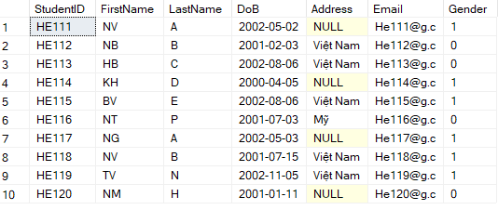

1. Table Lecture

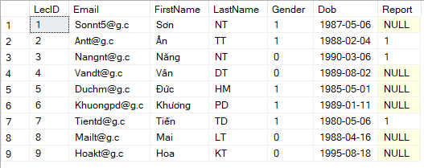

1. Table Classs

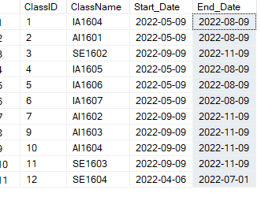

1. Table Subject

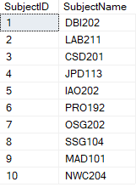

1. Table Term

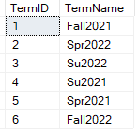

## Query 1 : Update

Update Lecture

Set Report = 2

where LecID =3

## Query 2 : Delete

Delete top1

From Students s

Where s.StudentID = 1

## Query 3

-- A QUERY THAT USES ORDER BY --

SELECT * FROM Students ORDER BY [FirstName], [LastName]

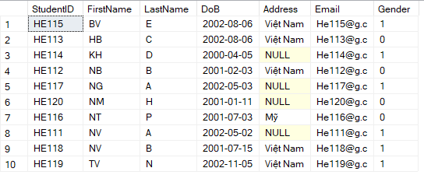

## Query 4

-- A QUERY THAT USES INNER JOIN --

Select *

From Students s Inner join Student_Class sc on s.StudentID = sc.StudentID

Inner join Class c on sc.ClassID = c.ClassID

Order by s.StudentID ASC

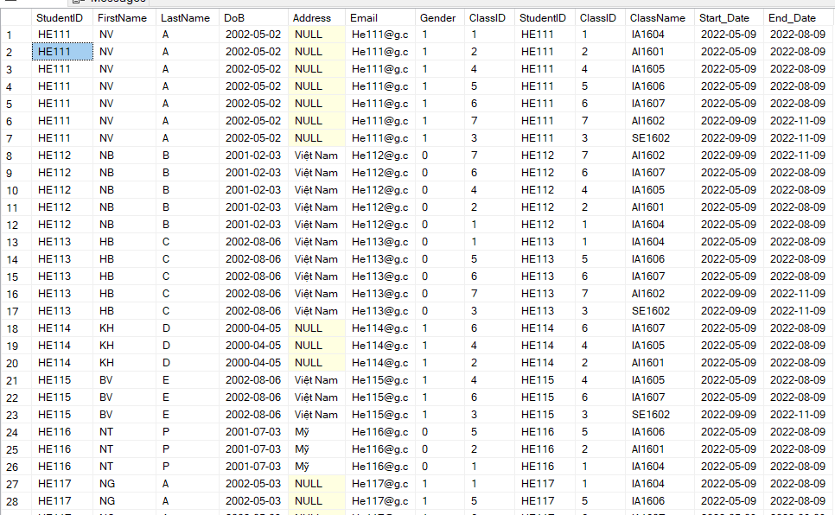

## Query 5 : Danh sách sinh viên 1 lớp

select s.*,c.ClassName from Students s join Student_Class sc on sc.StudentID = s.StudentID

join Class c on c.ClassID = sc.ClassID

## where sc.ClassId = ?

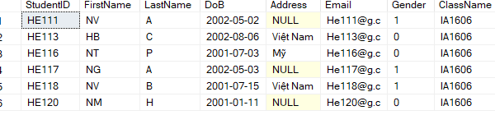

## Query 6 : Điểm của 1 sinh viên

select s.*,g.SubjectID,g.total,g.status

from Students s join Student_Subject sb on s.StudentID = sb.StudentID

join Gradess g on g.SubjectID = sb.SubjectID where s.StudentID = 'HE111'

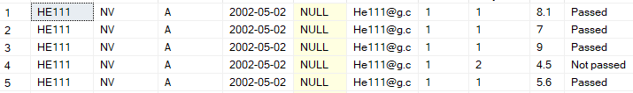

## Query 7 : Danh sách sinh viên học 1 môn

select * from Students s join Student_Subject sb on s.StudentID = sb.StudentID where sb.SubjectID = 3

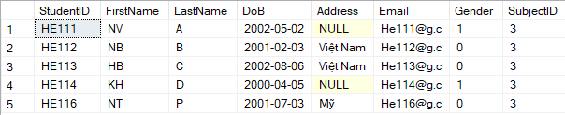

## Query 8 : Danh sách môn trong 1 kì

select s.SubjectName,t.TermName from Term t join Subject_Term st on t.TermID = st.TermID

join Subjects s on s.SubjectID = st.SubjectID where st.TermID = 2

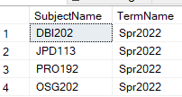

## Query 9 : Danh sách xem 1 học sinh ở những lớp nào

Create Procedure PR1 @StudentID varchar(10)

AS

BEGIN

select *

From Student_Class

where StudentID = @StudentID

END

execute PR1 'HE111'

## Query 10 : Danh sách xem bảng điểm của 1 môn

select * from Subjects s, Gradess g

where s.SubjectID = g.SubjectID and s.SubjectId = 4

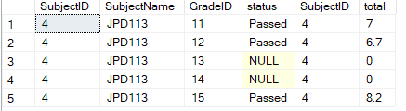

**IV . Tổng kết và đánh giá**

Như vậy, Cơ bản cở sở dữ liệu đánh giá và truy xuất thông tin quản lí điểm sinh viên đã được hoàn thành.

Cách xây dựng cơ sở dữ liệu này đã đáp ứng được các yêu cầu như:

thêm, sửa, xóa, truy xuất và dễ dàng theo dõi được hệ thống điểm của từng sinh viên, lớp học và đảm bảo tính chính xác trong từng thời gian chỉnh sửa.Về cơ bản database chỉ hoàn thiện gần như ở mức cơ bản cho người dung và cơ sở dữ liệu này vẫn chưa được đánh giá và trình bày một cách khoa học để có thể được kế thừa và phát triển ở các lĩnh vực khác. Đây là bài làm cá nhân và là bài đầu tiên tự tay thiết kế.Cảm ơn mọi người đã theo dõi tiến trình xây dựng cơ sở dữ liệu " Quản Lí Điểm FLM "và rất mong có được sự góp ý đến từ người xem để Database có thể trở nên hoàn thiện hơn và ứng dụng được vào trong cuộc sống.

Xin trân thành cảm ơn.

Người phát triển

Tạ Việt Nam - HE160666

IA1604